Experiment 27. Prolog Program to Implement Best First Search Algorithm

Aim
To write a Prolog program to implement the Best First Search algorithm using heuristic values.

Algorithm
- Start from the initial node.
- Store the nodes along with their heuristic values.
- Select the node having the lowest heuristic value.
- Expand the selected node.
- Repeat the process until the goal node is reached.
- Display the path from the start node to the goal node.

Program:
edge(a,b).
edge(a,c).
edge(b,d).
edge(b,e).
edge(c,f).
edge(c,g).
edge(e,h).
edge(f,h).
heuristic(a,7).
heuristic(b,6).
heuristic(c,5).
heuristic(d,4).
heuristic(e,3).
heuristic(f,2).
heuristic(g,6).
heuristic(h,0).
best_first(Start,Goal,Path) :-
best_search(Start,Goal,[Start],RevPath),
reverse(RevPath,Path).
best_search(Goal,Goal,Visited,Visited).
best_search(Current,Goal,Visited,Path) :-
findall(H-Next,
(edge(Current,Next),
\+ member(Next,Visited),
heuristic(Next,H)),
List),
List \= [],
choose_best(List,Next),
best_search(Next,Goal,[Next|Visited],Path).
choose_best([_-N],N).
choose_best([H1-N1,H2-N2|Rest],Best) :-
H1 =< H2,
choose_best([H1-N1|Rest],Best).
choose_best([H1-N1,H2-N2|Rest],Best) :-
H1 > H2,
choose_best([H2-N2|Rest],Best).

Query:
?- best_first(a, h, Path).

Output
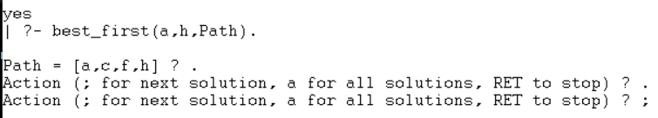

Result
Thus, the Best First Search algorithm was successfully implemented using Prolog.

Experiment 28. Prolog Program for Medical Diagnosis

Aim
To write a Prolog program to implement a simple medical diagnosis system based on symptoms.

Algorithm
- Start the program.
- Define symptoms for different diseases.
- Define rules connecting symptoms with diseases.
- Query the symptoms of a patient.
- Use the rules to identify the possible disease.
- Display the diagnosis.
- Stop.

Program
symptom(ravi, fever).
symptom(ravi, cough).
symptom(ravi, body_pain).
symptom(priya, fever).
symptom(priya, sneezing).
symptom(priya, running_nose).
symptom(anu, stomach_pain).
symptom(anu, vomiting).
diagnosis(Person, flu) :-
symptom(Person, fever),
symptom(Person, cough),
symptom(Person, body_pain).
diagnosis(Person, common_cold) :-
symptom(Person, fever),
symptom(Person, sneezing),
symptom(Person, running_nose).
diagnosis(Person, food_poisoning) :-
symptom(Person, stomach_pain),
symptom(Person, vomiting).

Query 1
?- diagnosis(ravi, Disease).

Output
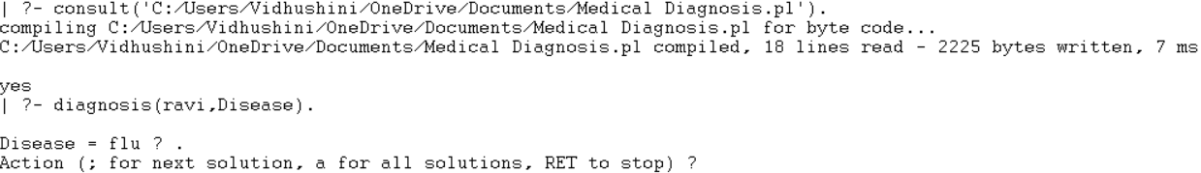

Result
Thus, a simple medical diagnosis system was successfully implemented using Prolog.

Experiment 29. Prolog Program for Forward Chaining

Aim
To write a Prolog program to implement Forward Chaining and demonstrate the required queries.

Algorithm
- Start with known facts.
- Check the rules whose conditions match the known facts.
- Apply the matching rules.
- Add the newly derived facts to the knowledge base.
- Continue until the required conclusion is obtained or no new fact can be derived.
- Display the result.

Program
fact(sunny).
fact(weekend).
rule(go_out) :-
fact(sunny),
fact(weekend).
rule(play_cricket) :-
fact(go_out).
derive(X) :-
rule(X),
assertz(fact(X)),
write(X),
write(' is derived.'), nl.

Query 1
?- rule(go_out).

Output
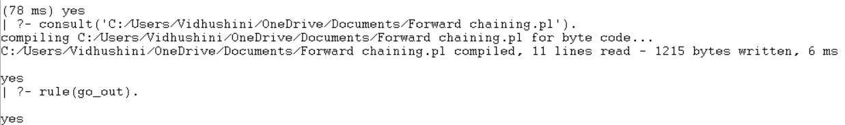

Result
Thus, the Forward Chaining concept was successfully implemented in Prolog by deriving new facts from existing facts and rules.

Experiment 30. Prolog Program for Backward Chaining

Aim
To write a Prolog program to implement Backward Chaining and demonstrate the required queries.

Algorithm
- Start with a goal.
- Check whether the goal is a known fact.
- If it is not a fact, find a rule whose conclusion matches the goal.
- Treat the rule's conditions as sub-goals.
- Recursively prove each sub-goal.
- If all sub-goals are true, the original goal is true.
- Display the result.

Program
rain.
cloudy.
wet_ground :-
rain.
carry_umbrella :-
rain,
cloudy.
go_out :-
carry_umbrella.

Query 1
?- wet_ground.
?- carry_umbrella.
?- go_out.

Output
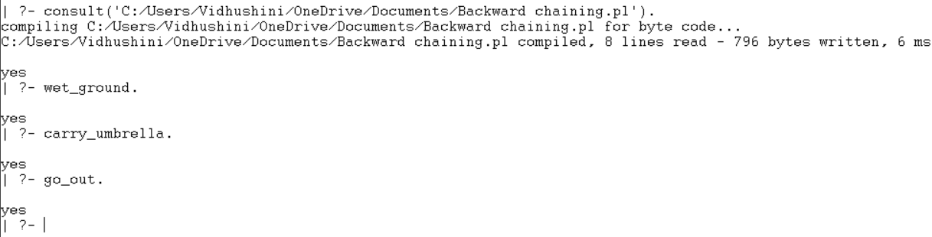

Result
Thus, the Backward Chaining mechanism was successfully demonstrated by starting from the goal and checking the required conditions.

